**WEEK-2(From Dt 22-05-2023 to Dt 28-05-2023)**

**Detailed Report**: In the second week we went to cotton fields to know about the cotton and the problems faced to grow them.

* Cotton is World’s favorite fiber. Its beauty, comfort, durability and versatility make it the perfect choices for clothing, bedding, textiles and many other products. India is the World’s largest producer of cotton and the United States has been the largest exporter for many years.
* Cotton farming, a vital agricultural sector, plays a significant role in the global textile industry. However, cotton farmers face numerous challenges that impact their productivity, profitability and sustainability.
* Cotton farming, a vital agricultural sector, plays a significant role in the global textile industry. However, cotton farmers face numerous challenges that impact their productivity, profitability and sustainability.
* Similarly, Lemon tress are a rich source of vitamin c, calcium, magnesium, iron. This

minerals are maintaining strong bones maintaining a healthy. Even though the lemons are good for health but it is not easy to grow them. Farmers faces various problem to grow them.

* To know the problem we decided to go to cotton field & lemon fields in Chiruvella Khandrika, we identified the different types of problems, the problems are high cost of fertilizes, pest and disease infestation, labour wages, less MSP and low rate return, nutritional deficiencies.

# Based on our research the solution to the problems are:

* + Implementing an integrated weed management approach, including cultural mechanical and chemical methods.
  + Instead of paying workers a fixed daily or hourly wage, they are compensated based on the quantity of cotton they harvest or the number of tasks they complete.
  + Rotating crops to disrupt weed cycles and to reduce weed pressure.Utilize precision farming technologies such as GPS-guided equipment, drones and sensors.
  + Collecting and storing rainwater to supplement irrigation needs during dry periods.
  + Conduct regular soil tests to determine the specific nutrient needs of your cotton fields. This will help you apply fertilizers more efficiently, avoiding over-application and unnecessary costs.
  + Utilize precision farming technologies, such as variable rate application and GPS-guided equipment, to apply fertilizers only where they are needed most. This targeted approach ensures efficient use of fertilizers, minimizing waste and cost.
  + Conducting soil testing to access the nutrient levels. Based on that result apply balanced fertilizers.

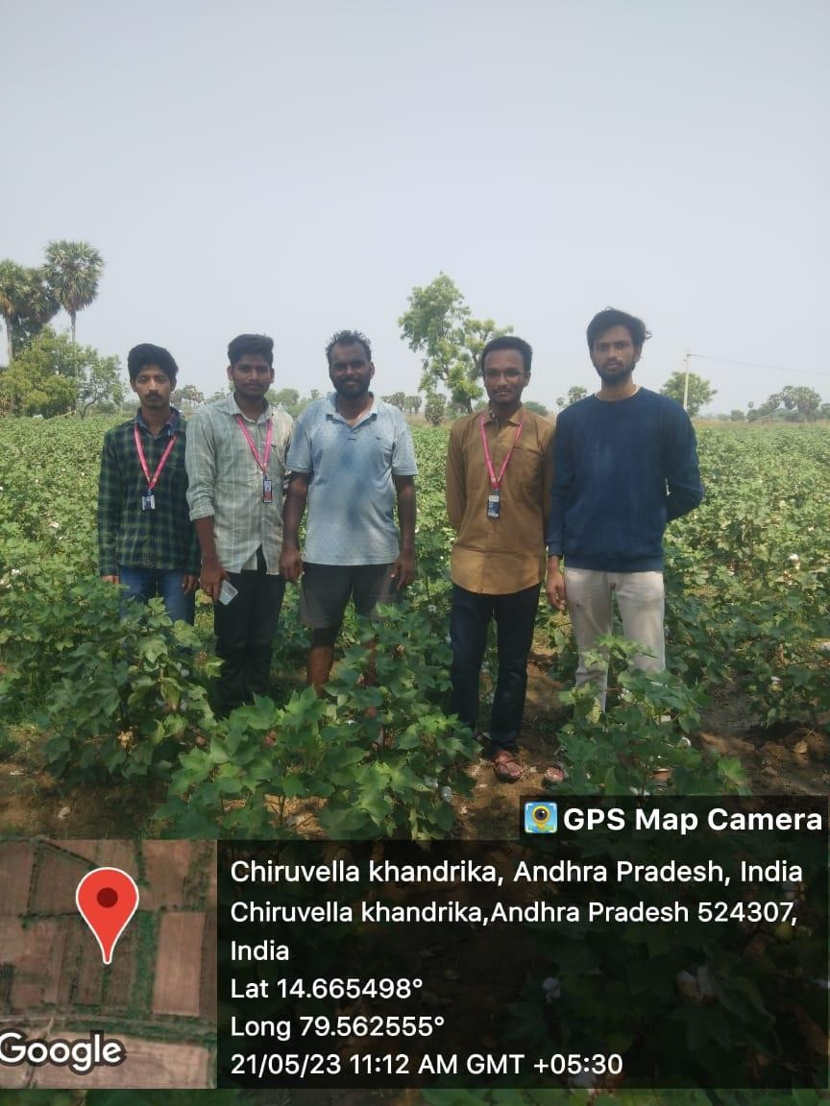

In the above figure we are meet the farmer name Santosh in chiruvella khandrika and asked that farmer on various questions based on that questions we are identified different problems faced by that farmer. Majorly the farmer is faced high cost of fertilizers, labour wages, less MSP and etc.

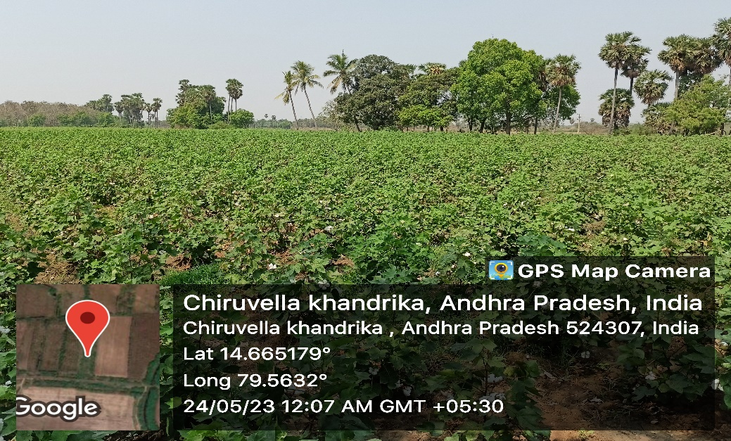

In above figure is show the fields of Santosh the farmer had 1 acer of land in that one acre he was growing both cotton and wheat Kharif crop, used in making clothes and in the textile industry. This Kharif crop requires 6-8 months to mature. The harvesting and sowing time of crops differ in different regions, depending upon the climate conditions.

GUIDE SIGNATURE PROJECT COORDINATE SIGNATURE HOD SIGNATURE

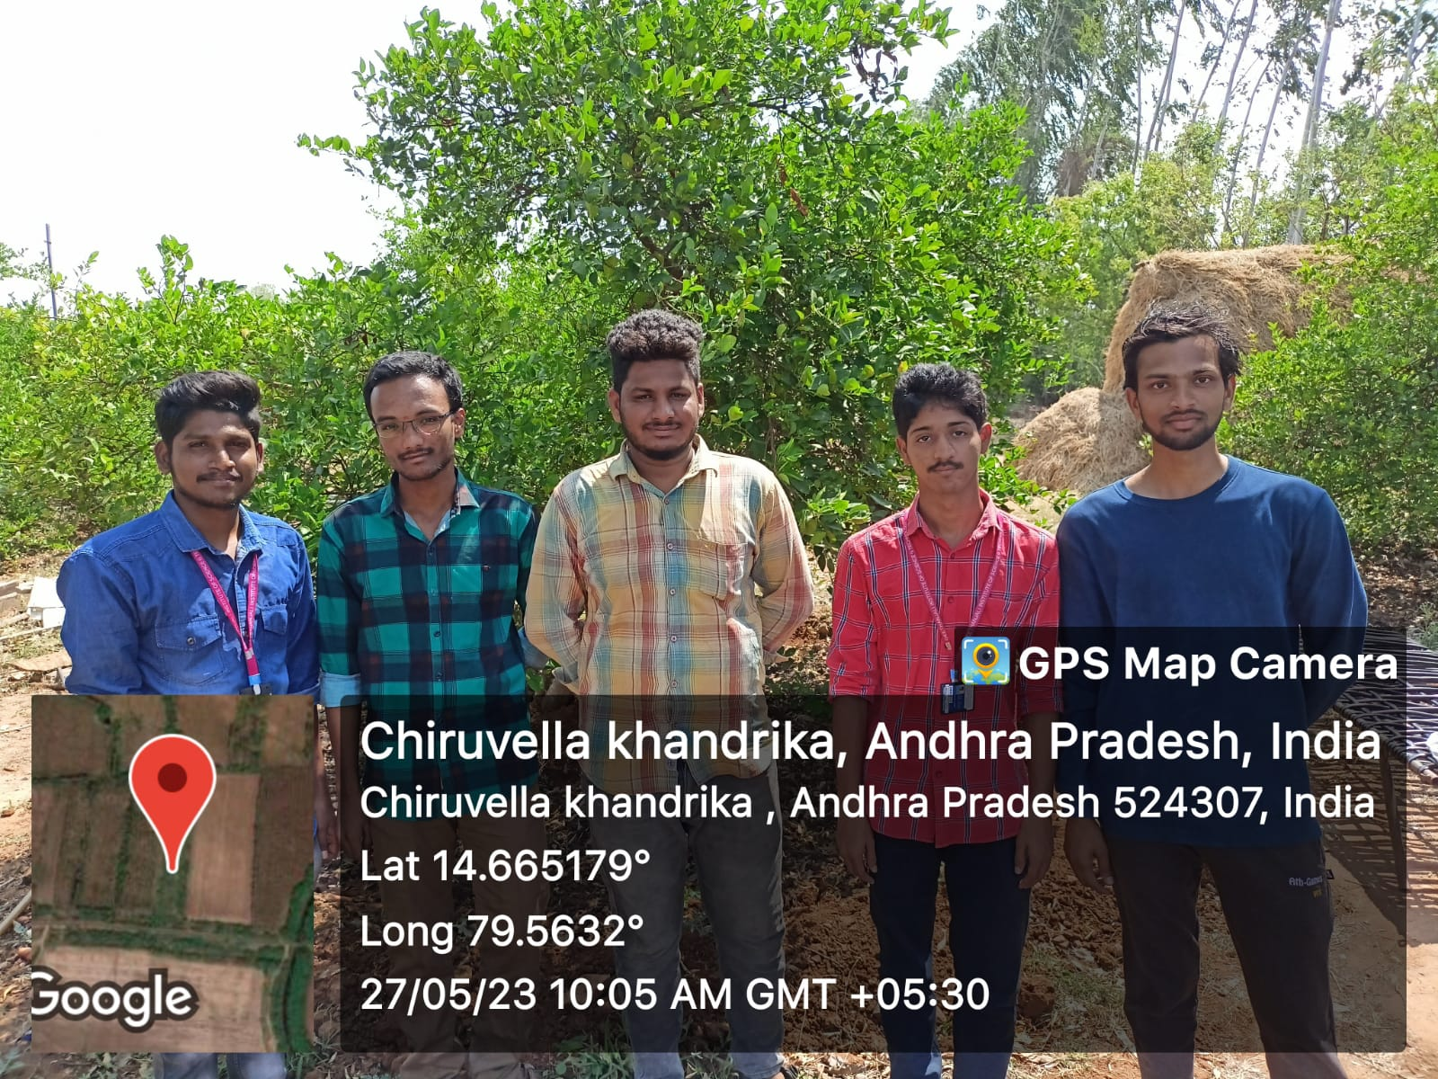

In the week-2 of our project we are also visiting lemon fields and meet the farmer name Hari Prasad we may asked the different types of question like what are the problems faced by that farmer during his crop production based our questions he answered some of the question based on that his crop production and he also told to us how much period that lemon crop is produced and we are given some solutions to that farmer placed a awareness camp to that locality farmers who are produced the lemon crop in their fields.

GUIDE SIGNATURE PROJECT COORDINATER SIGNATURE HOD SIGNATURE